Контрольная работа 3 класс (1 вариант)

№1. Look and complete.
ch_i_ 2) c_ok_r 3)m_rr_r 4) f_id_e

№2. Read and choose.
Where are the box/boxes?
These are Kate’s babies/baby.
This is Peter’s baby/babies.
Whose are these glass/glasses?

№3.Look, read and choose.
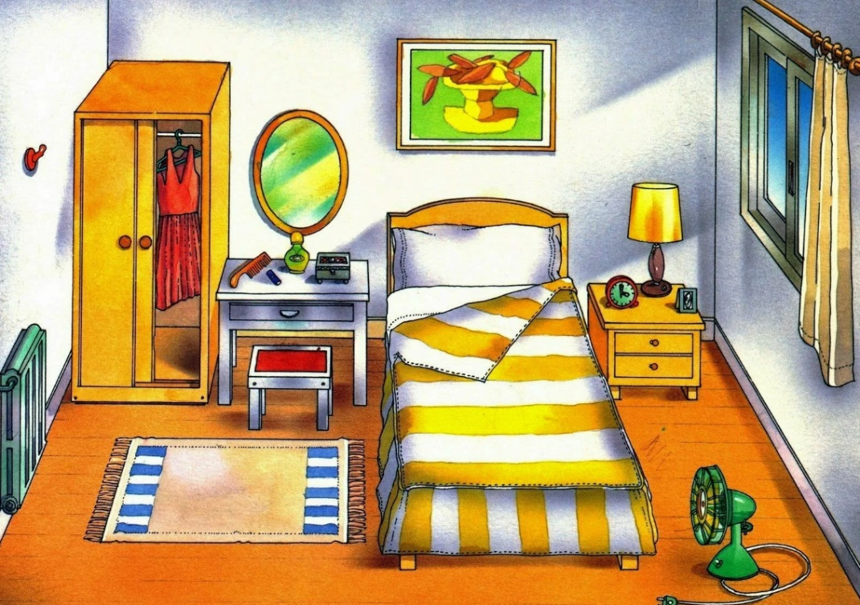

This is/are a bed in front of/behind the window.
This is/are a mirror on/under the table.
This is/are a lamp in/next to the bed.
This is/are a picture on/in front of the wall.

№4.Write the plurals.
a dish-______________; a leaf-________________;
a fox-_______________; a wolf-________________ ;
a bench-_____________; a family -______________;
a box-_______________; a balcony-______________.

№5.Read and match.
How many fridges are there? A) In the kitchen.
Where is Mike? B) Only two.
What’s in the fridge? C) Five bananas.

№6.Read and write yes or no.
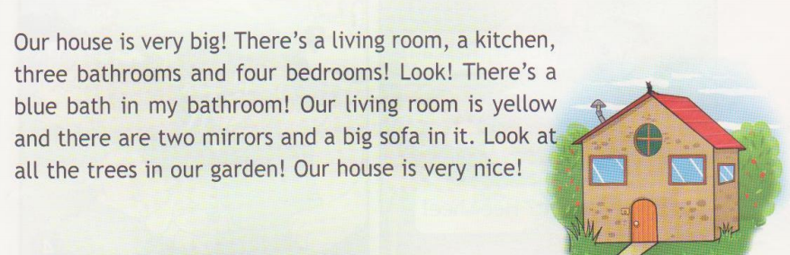
There are three bedrooms in the house.
There are two kitchens in the house.
There is one mirror in the living room.
The house is not very nice.
There is a blue bath in the bathroom.
There is a small sofa in the living room.
Контрольная работа 3 класс (2 вариант)

№1. Look and complete.
t_bl_ 2) c_ok_r 3) s_f_ 4) f_id_e
​​​​​​​
№2. Read and choose.
Where are the fox/foxes?
This is Mary’s family/families.
3.This is Bob’s box/boxes.
4.Whose are these dress/dresses?

№3.Look, read and choose.
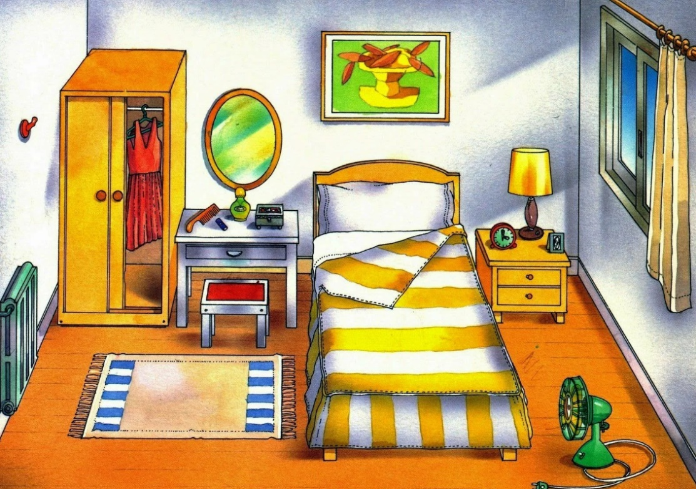
1.This is/are a picture in front of/near the window.
2.This is/are a chair on/under the table.
3.This is/are a lamp on/next to the bed.
4.This is/are a picture on/above of the bed.

№4.Write the plurals.
a wish-______________; a leaf-________________;
a box-_______________; a shelf-_______________ ;
a beach-_____________; a baby -______________;
a box-_______________; a balcony-______________.

№5.Read and match.
1.How many dresses are there? A) Five lemons.
2.Where is Mike? B) Only three.
3.What’s in the fridge? C) In the living room.

№6.Read and write yes or no.
1.There are four bedrooms in the house.
2.There is one tree in the garden.
3.There are three mirrors in the living room.
4.The house is very nice.
5.There is a red bath in the bathroom.
6.There is a big sofa in the living room.

